

GROUP ASSIGNMENT
TECHNOLOGY PARK MALAYSIA
CT042-3-1-IDB
INTRODUCTION TO DATABASE
APD1F2409CS/APD1F2409CS(AI)

LECTURER : Ms Yogeswari Muthusamy
CONTENT : PART 2 – GROUP COMPONENT
HAND OUT DATE : 29 OCTOBER 2024
HAND IN DATE : 14 JANUARY 2024
GROUP NUMBER : 2
No. | Group Member | TP Number
1 | Lee Chong Yew (Group Leader) | TP084402
2 | Roger Rusdianto Purnomo | TP075718
3 | Kay Nouvell Sidik | TP079470
4 | Gerrend Alfredo | TP081484
5 | Sonny Sanputra | TP084754

Table of Contents
Section 1 - Database Schema 4
1.1 Entity Relationship Diagram 4
1.2 Database Diagram 5
Section 2 - SQL - Data Definition Language (DDL) 6
2.1 Create Database 6
2.2 Members Table 6
2.3 Insert Members Table Data 7
2.4 Create Category Table 8
2.5 Insert Category Table Data 8
2.6 Create Items Table 9
2.7 Insert Items Table Data 10
2.8 Create Barcodes Table 11
2.9 Insert Barcodes Table Data 13
2.10 Create Loans Table 14
2.11 Insert Loans Table Data 15
2.12 Create Rooms Table 15
2.13 Insert Rooms Table Data 17
2.14 Create Reservations Table 18
2.15 Insert Reservations Table Data 19
Section 3 - SQL - Data Manipulation Language (DML) 20
3.1 Question 1 - Sonny Sanputra (TP084754) 20
3.1.1 SQL Code 20
3.1.2 Query Result 20
3.1.3 Explanation 21
3.2 Question 2 - Sonny Sanputra (TP084754) 23
3.2.1 SQL Code 23
3.2.2 Query Result 24
3.2.3 Explanation 24
3.3 Question 3 - Roger Rusdijanto Purnomo (TP075718) 28
3.3.1 SQL Code 28
3.3.2 Query Result 28
3.3.3 Explanation 28
3.4 Question 4 - Lee Chong Yew (TP084402) 30
3.4.1 SQL Code 30
3.4.2 Query Result 30
3.4.3 Explanation 31
3.5 Question 5 - Gerrend Alfredo (TP081484) 33
3.5.1 SQL Code 33
3.5.2 Query Results 34
3.5.3 Explanation 35
3.6 Question 6 - Kay Nouvell Sidik (TP079470) 38
3.6.1 SQL Code 38
3.6.2 Query Result 39
3.6.3 Explanation 39
3.7 Question 7 - Roger Rusdijanto Purnomo (TP075718) 42
3.7.1 SQL Code 42
3.7.2 Query Result 42
3.7.3 Explanation 43
3.8 Question 8 - Gerrend Alfredo (TP081484) 44
3.8.1 SQL Code 44
3.8.2 Query Results 44
3.8.3 Explanation 45
3.9 Question 9 - Lee Chong Yew (TP084402) 48
3.9.1 SQL Code 48
3.9.2 Query Results 48
3.9.3 Explanation 49
3.10 Question 10 - Kay Nouvell Sidik (TP079470) 50
3.10.1 SQL Code 50
3.10.2 Query Result 50
3.10.3 Explanation 51
3.11 Question 11 - Lee Chong Yew (TP084402) 52
3.11.1 SQL Code 52
3.11.2 Query Results 52
3.11.3 Explanation 53
3.12 Question 12 - Sonny Sanputra (TP084754) 54
3.12.1 SQL Code 54
3.12.2 Query Result 54
3.12.3 Explanation 55
3.13 Question 13 - Kay Nouvell Sidik (TP079470) 57
3.13.1 SQL Code 57
3.13.2 Query Result 57
3.13.3 Explanation 58
3.14 Question 14 - Roger Rusdianto Purnomo (TP075718) 60
3.14.1 SQL Code 60
3.14.2 Query Result 60
3.14.3 Explanation 61
3.15 Question 15 - Gerrend Alfredo (TP081484) 63
3.15.1 SQL Code 63
3.15.2 Query Result 63
3.15.3 Explanation 64
Section 4 - References 66
Section 5 - Workload Matrix 67

Section 1 - Database Schema

1.1 Entity Relationship Diagram
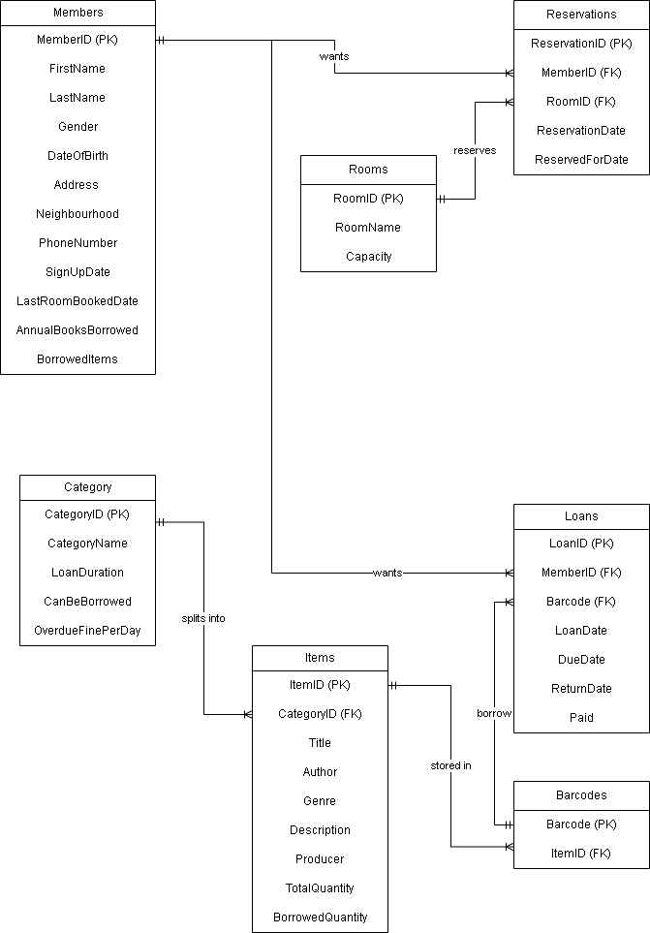
Figure 1.1: Entity Relationship Diagram (ERD)

1.2 Database Diagram
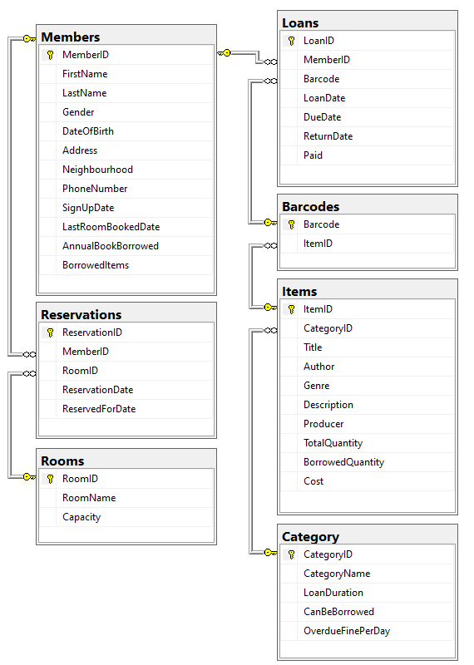
Figure 1.2: Database Diagram produced using SSMS

Section 2 - SQL - Data Definition Language (DDL)

2.1 Create Database
Figure 2.1.1: DDL used to create the database named LibrarySystem

2.2 Members Table
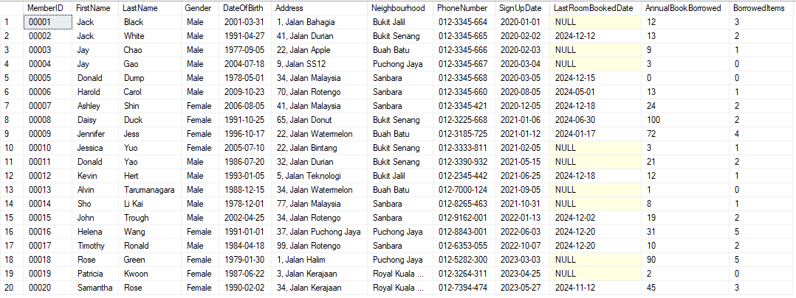Figure 2.2.1: Members table populated with data

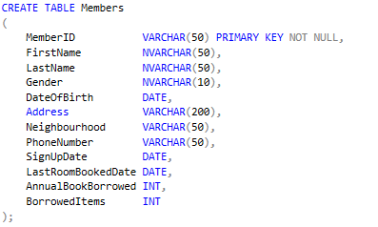
Figure 2.2.2: DDL used to create Members table

2.3 Insert Members Table Data
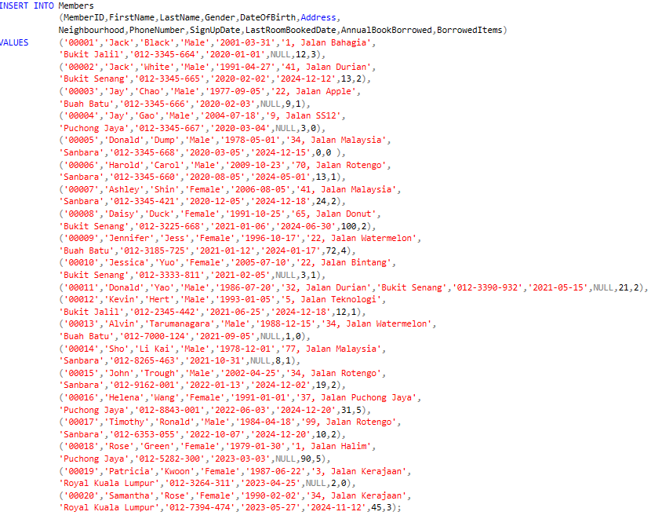
Figure 2.3.1: DML used to insert data into Members table

2.4 Create Category Table
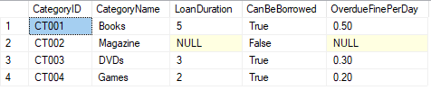
Figure 2.4.1: Category table populated with data

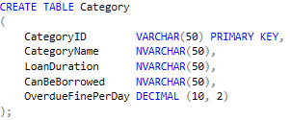
Figure 2.4.2: DDL used to create Category table

2.5 Insert Category Table Data
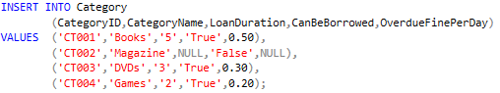
Figure 2.5.1: DML used to insert data into Category table

2.6 Create Items Table
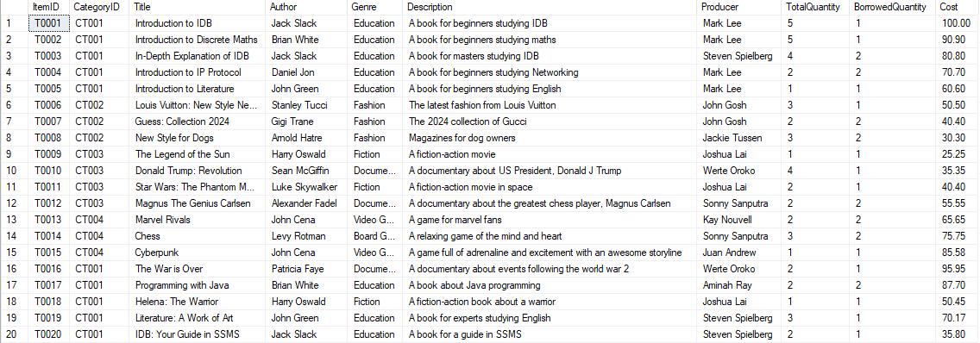
Figure 2.6.1: Items table populated with data

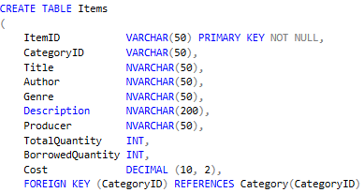
Figure 2.6.2: DDL used to create Items table

2.7 Insert Items Table Data
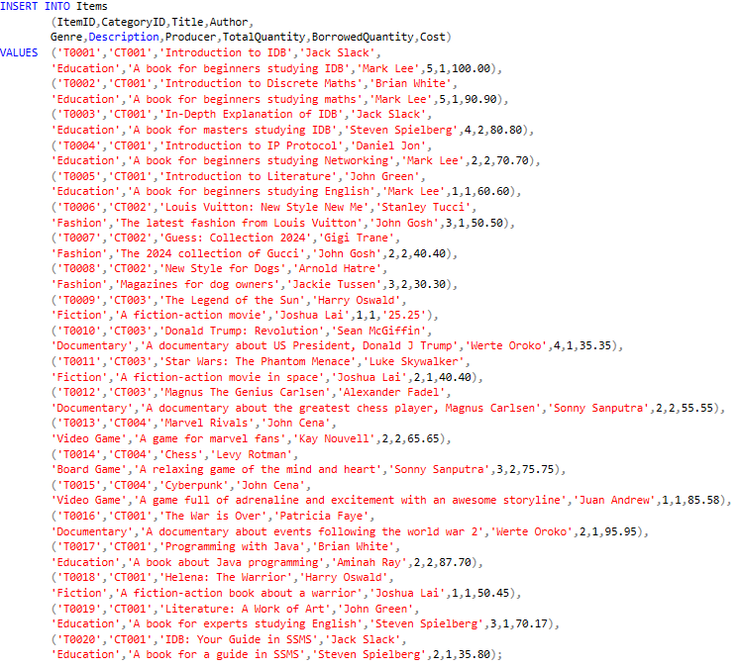
Figure 2.7.1: DML used to insert data into Items table

2.8 Create Barcodes Table
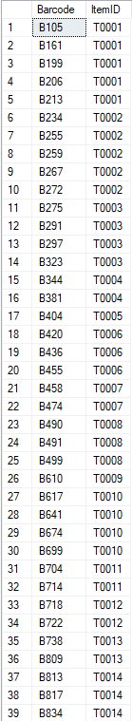
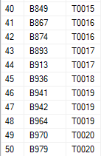
Figure 2.8.1: Barcodes table

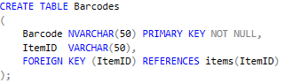
Figure 2.8.2: DDL used to create Barcodes table

2.9 Insert Barcodes Table Data
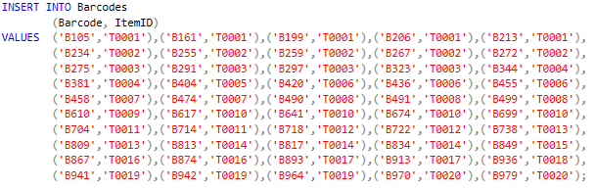
Figure 2.9.1: DML used to insert data into Barcodes table

2.10 Create Loans Table
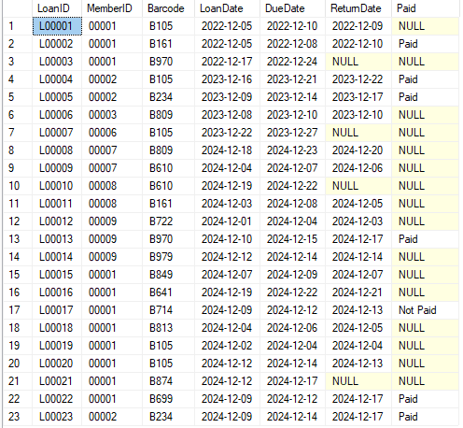
Figure 2.10.1: Loans table populated with data

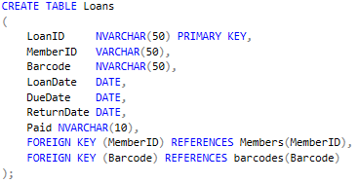
Figure 2.10.2: DDL used to create Loans table

2.11 Insert Loans Table Data
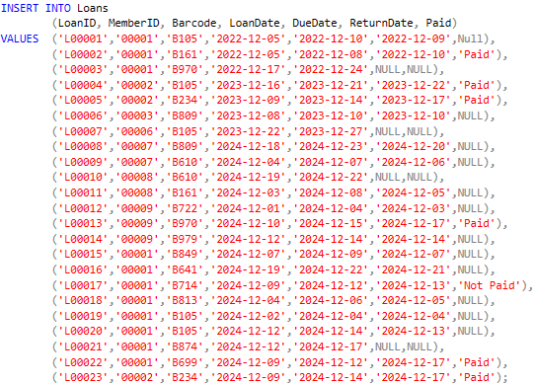
Figure 2.11.1: DML used to insert data into Loans table

2.12 Create Rooms Table
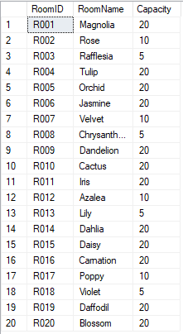
Figure 2.12.1: Rooms table populated with data

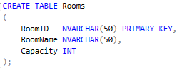
Figure 2.12.2: DDL used to create Rooms table

2.13 Insert Rooms Table Data
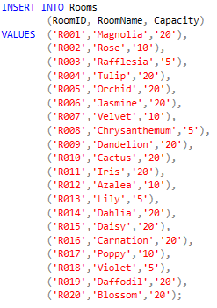
Figure 2.13.1: DML used to insert data into Rooms table

2.14 Create Reservations Table
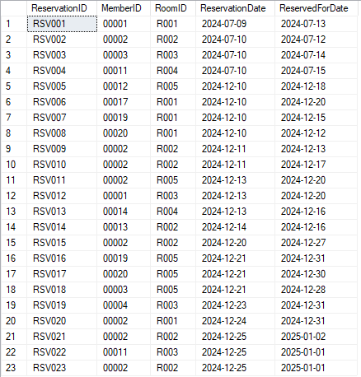
Figure 2.14.1: Reservations table populated with data

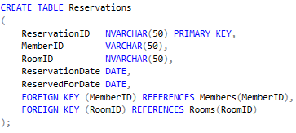
Figure 2.14.2: DDL used to create Reservations table

2.15 Insert Reservations Table Data
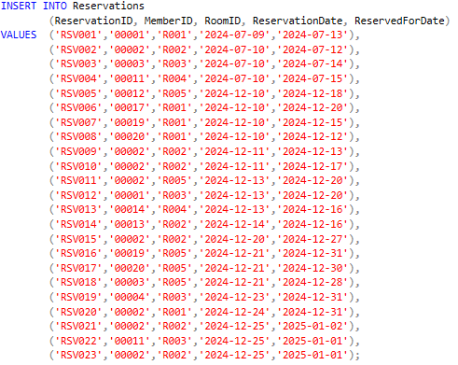
Figure 2.15.1: DML used to insert data into Reservations table

Section 3 - SQL - Data Manipulation Language (DML)

3.1 Question 1 - Sonny Sanputra (TP084754)
List all the items name, descriptions, item name and category description that are currently not on loan and available for loan. Order the result by category.

3.1.1 SQL Code
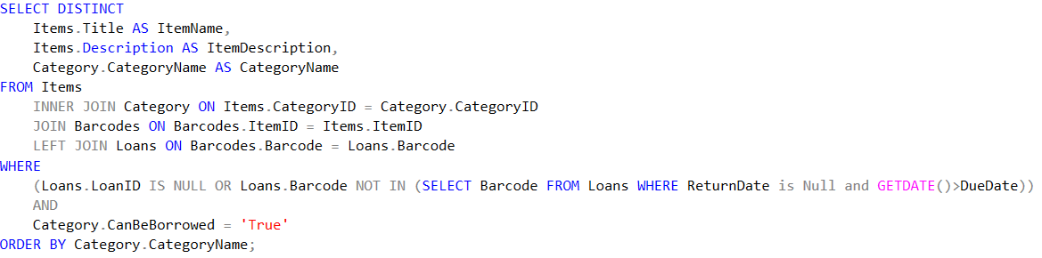
Figure 3.1.1: DML query for Question 1

3.1.2 Query Result
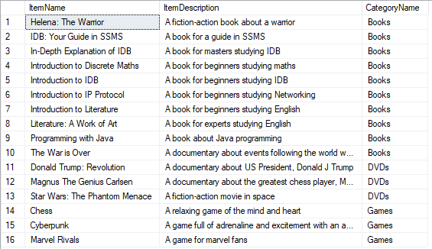
Figure 3.1.2: Query result for Question 1

3.1.3 Explanation
SELECT DISTINCT
Items.Title AS ItemName,
Items.Description AS ItemDescription,
Category.CategoryName AS CategoryName
FROM Items
The SELECT clause Returns unique items and their details and prevents them from repeating when compared with the Loans table.

FROM Items
INNER JOIN Category ON Items.CategoryID = Category.CategoryID
JOIN Barcodes ON Barcodes.ItemID = Items.ItemID
LEFT JOIN Loans ON Barcodes.Barcode = Loans.Barcode
The JOIN clause is used to link two tables using an identifier:
- INNER JOIN Category ON Items.CategoryID = Category.CategoryID links the Items and Category table using CategoryID. It returns Items that contain CategoryID in both tables.
- JOIN Barcodes ON Barcodes.ItemID = Items.ItemID links the Items and Barcodes table using ItemID. It includes the ItemID that exists in both tables.
- LEFT JOIN Loans ON Barcodes.Barcode = Loans.Barcode links the Barcodes and Loans table using Barcode. It returns all Barcodes that are contained in the Loans and where Barcode does not exist, all the data in the Loans table will be null for that Barcode.

WHERE
(Loans.LoanID IS NULL OR Loans.Barcode NOT IN (SELECT Barcode FROM Loans WHERE ReturnDate is Null and GETDATE()>DueDate))
AND
Category.CanBeBorrowed = 'True'
WHERE is used to filter the records based on the conditions:
- (Loans.LoanID IS NULL OR Loans.Barcode NOT IN (SELECT Barcode FROM Loans WHERE ReturnDate is Null and GETDATE()>DueDate)) will return records where the LoanID is NULL (The barcodes have not been loaned) and return records which are currently not being borrowed)
- Category.CanBeBorrowed = 'True' will return records that have the category which allows members to borrow.
- The overall WHERE will include only those items which are not all currently being borrowed and are allowed to be borrowed.

ORDER BY Category.CategoryName
The ORDER clause is use to order the result according to the Category Name in ascending order.

3.2 Question 2 - Sonny Sanputra (TP084754)
Show members who had paid overdue more than 2 times for rental items. The results must consist of their first name, last name, contact number, number of overdue, and total due amount. Show the results according to their neighbourhood.

3.2.1 SQL Code
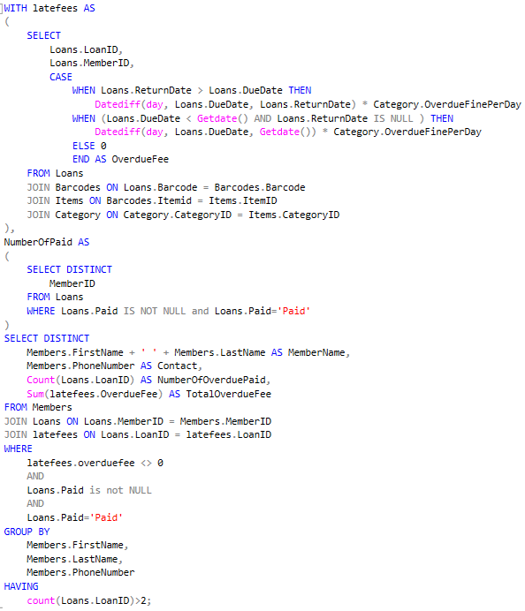
Figure 3.2.1: DML query for Question 2

3.2.2 Query Result
Figure 3.2.2: Query result for Question 2

3.2.3 Explanation
WITH latefees AS (...), NumberOfPaid AS (...)
The WITH(...) clause creates a Common Table Expression (CTE) that is used to perform queries and also acts as a sub-query for the main query.

(SELECT
Loans.LoanID,
Loans.MemberID,
CASE
WHEN Loans.ReturnDate > Loans.DueDate THEN
Datediff(day, Loans.DueDate, Loans.ReturnDate) * Category.OverdueFinePerDay
WHEN (Loans.DueDate < Getdate() AND Loans.ReturnDate IS NULL ) THEN
Datediff(day, Loans.DueDate, Getdate()) * Category.OverdueFinePerDay
ELSE 0
END AS OverdueFee
FROM Loans
JOIN Barcodes ON Loans.Barcode = Barcodes.Barcode
JOIN Items ON Barcodes.Itemid = Items.ItemID
JOIN Category ON Category.CategoryID = Items.CategoryID),
Inside the latefees:
- The SELECT clause returns the LoanID, MemberID and a calculated OverdueFee for each Loan.
- The CASE clause will do a specific function when a condition is met. The conditions is as follows:
- When the return date is higher than the due date, it means that the item is returned late and the fee is calculated by multiplying the difference between dates and fineperday based on their category.
- When the return date is null, it means that the item is late and not returned and the fee is calculated by multiplying the difference between the due date and current date with fineperday based on their category.
- If any of the conditions is not met, the overdue is zero (0).

- The JOIN clause will link two tables with each other using an identifier. The JOIN clause used is as follows:
- JOIN Barcodes ON Loans.Barcode = Barcodes.Barcode links the Loans and Barcodes table using Barcode. It returns Barcodes that exist in both tables.
- JOIN Items ON Barcodes.Itemid = Items.ItemID links the Items and Barcodes table using ItemID. It includes the ItemID that exists in both tables.
- JOIN Category ON Category.CategoryID = Items.CategoryID links the Items and Category table using CategoryID. It includes CategoryID that exists in both tables.

(SELECT DISTINCT
MemberID
FROM Loans
WHERE Loans.Paid IS NOT NULL and Loans.Paid='Paid')
In the NumberOfPaid:
- The SELECT DISTINCT clause returns unique records based on the MemberID from the Loans table.
- The WHERE clause gives a condition and filters records so only those records where the loans are paid and not null can be included.

SELECT DISTINCT
Members.FirstName + ' ' + Members.LastName AS MemberName,
Members.PhoneNumber AS Contact,
Count(Loans.LoanID) AS NumberOfOverduePaid,
Sum(latefees.OverdueFee) AS TotalOverdueFee
FROM Members
- The SELECT DISTINCT clause returns unique records based on the Members table to prevent any repetitive members.
- The Count(Loans.LoanID) will count how many loans are paid by each member and returns them with the identifier NumberOfOverduePaid.
- The Sum(latefees.OverdueFee) will calculate the total amount of fees that have been paid by the members.
FROM MEMBERS
JOIN Loans ON Loans.MemberID = Members.MemberID
JOIN latefees ON Loans.LoanID = latefees.LoanID
The JOIN clause will link two tables with each other using an identifier. The JOIN clause used is as follows:
- JOIN Loans ON Loans.MemberID = Members.MemberID links the Members and Loans table based on the MemberID. It will return records in which MemberID exists in both tables.
- JOIN latefees ON Loans.LoanID = latefees.LoanID links the latefees and Loans table using LoanID. It will return records which have LoanID in both tables.

WHERE
latefees.overduefee <> 0
AND
Loans.Paid is not NULL
AND
Loans.Paid='Paid'
WHERE is used to filter the records based on the conditions:
- latefees.overduefee <> 0 will return records where the overduefee is zero, meaning they have been returned on time and no fees are assigned.
- Loans.Paid is not NULL will return records that has paid value of not NULL, meaning they have paid or not paid, NULL value refers to no fees due to on-time return.
- Loans.Paid=’Paid’ will return records where the fees have been paid by the member in that LoanID.

GROUP BY
Members.FirstName,
Members.LastName,
Members.PhoneNumber
The GROUP BY clause groups the data by member details (Members.FirstName, Members.LastName, Members.PhoneNumber) to prevent repetitive members data.

HAVING
count(Loans.LoanID)>2;
The HAVING clause will filter so that only members that have paid more than 2 times are included.

3.3 Question 3 - Roger Rusdijanto Purnomo (TP075718)
Display the active members and list of books they have borrowed in the years 2022 and 2023. The result must consist of members’ first name, last name, book name, and the borrow date. Sort the result by borrowed year in ascending order.

3.3.1 SQL Code
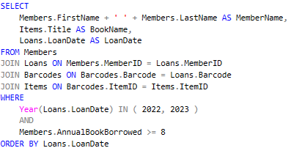
Figure 3.3.1: DML query for Question 3

3.3.2 Query Result
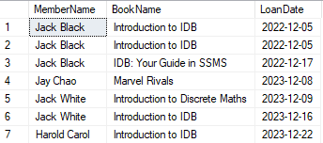
Figure 3.3.2: Query result for Question 3

3.3.3 Explanation
SELECT
Members.FirstName + ' ' + Members.LastName AS MemberName,
Items.Title AS BookName,
Loans.LoanDate AS LoanDate
FROM Members
The SELECT clause returns the members full name, book name and loan date based on the conditions that are set.

FROM Members
JOIN Loans ON Members.MemberID = Loans.MemberID
JOIN Barcodes ON Barcodes.Barcode = Loans.Barcode
JOIN Items ON Barcodes.ItemID = Items.ItemID
The JOIN clause is used to link two tables together using an identifier. The JOIN clause is as follows:
- JOIN Barcodes ON Loans.Barcode = Barcodes.Barcode links the Loans and Barcodes table using Barcode. It returns records which has Barcode in both tables
- JOIN Items ON Barcodes.Itemid = Items.ItemID links the Items and Barcodes table using ItemID. It returns Barcodes that contain ItemID in both tables.
- JOIN Loans ON Members.MemberID = Loans.MemberID links the Members and Loans table based on the MemberID. It will return records which have MemberID in both tables.

WHERE
Year(Loans.LoanDate) IN ( 2022, 2023 )
AND
Members.AnnualBookBorrowed >= 8
The WHERE clause is used to filter the records based on the conditions:
- Year(Loans.LoanDate) IN ( 2022, 2023 ) will return records where the loan occurs in the year 2022 and 2023.
- Members.AnnualBookBorrowed >= 8 will return records of which member is an active member.

ORDER BY Loans.LoanDate
The ORDER clause is used to order the result according to the loan date in a chronological order.

3.4 Question 4 - Lee Chong Yew (TP084402)
Show the members who have borrowed items at least 8 times this year. Display their name and the numbers of items they have borrowed.

3.4.1 SQL Code
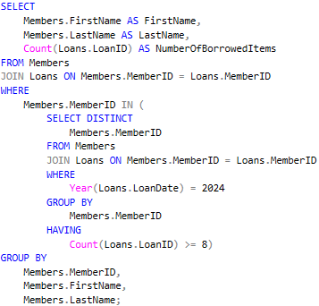
Figure 3.4.1: DML query for Question 4

3.4.2 Query Result
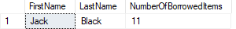
Figure 3.4.2: Query result for Question 4

3.4.3 Explanation
SELECT
Members.FirstName AS FirstName,
Members.LastName AS LastName,
Count(Loans.LoanID) AS NumberOfBorrowedItems
FROM Members
The SELECT clause will return the first name, last name and a calculated number of borrowed items by each member based on the conditions given.

FROM Members
JOIN Loans ON Members.MemberID = Loans.MemberID
The JOIN clause links the Loans table with the Members table based on the identifier MemberID. This will include only those MemberID that exists in the Loans table.

WHERE
Members.MemberID IN (...)
WHERE is used to filter the records where MemberID exists in the subquery.

SELECT DISTINCT
Members.MemberID
FROM Members
JOIN Loans ON Members.MemberID = Loans.MemberID
WHERE
Year(Loans.LoanDate) = 2024
GROUP BY
Members.MemberID
HAVING
Count(Loans.LoanID) >= 8
Inside the WHERE:
- SELECT DISTINCT Members.MemberID will return unique values of MemberID, preventing duplicate rows.
- FROM Members JOIN Loans ON Members.MemberID = Loans.MemberID will link the Members table with the Loans table using MemberID, where it will only include MemberID that exists in the Loans table.
- WHERE Year(Loans.LoanDate) = 2024 will filter the records to include the loans that occur during 2024.
- GROUP BY Members.MemberID will group the result of the number of items borrowed per member.
- HAVING Count(Loans.LoanID) >= 8 will include those members who borrowed at least 8 books in the year 2024.

GROUP BY
Members.MemberID,
Members.FirstName,
Members.LastName;
The GROUP BY clause groups the data by member details (Members.MemberID, Members.FirstName, Members.LastName) to prevent repetitive members data.

3.5 Question 5 - Gerrend Alfredo (TP081484)
Display the members’ name and contact number as well as name and description of the items borrowed the most. Order the result by category type.

3.5.1 SQL Code
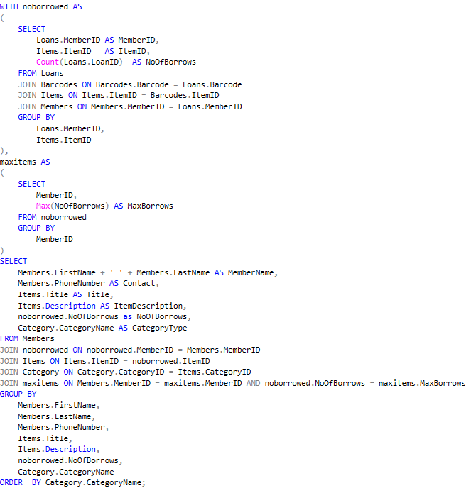
Figure 3.5.1: DML query for Question 5

3.5.2 Query Results
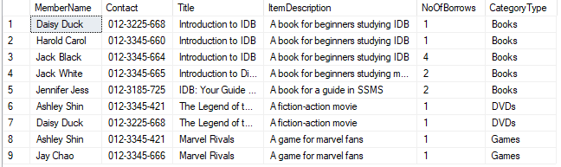
Figure 3.5.2: Query result for Question 5

3.5.3 Explanation
WITH noborrowed AS (...), maxitems AS (...)
The WITH(...) clause creates a temporary table that is used to perform queries and also acts as a sub-query for the main query.

(SELECT
Loans.MemberID AS MemberID,
Items.ItemID AS ItemID,
Count(Loans.LoanID) AS NoOfBorrows
FROM Loans
JOIN Barcodes ON Barcodes.Barcode = Loans.Barcode
JOIN Items ON Items.ItemID = Barcodes.ItemID
JOIN Members ON Members.MemberID = Loans.Memberid
GROUP BY
Loans.MemberID,
Items.ItemID
),
Inside the noborrowed:
- The SELECT clause will select Loans.MemberID, Items.ItemID, and a calculated number of borrows each member for each item has.
- The JOIN clause links two tables to each other through an identifier. The JOIN is as follows:
- JOIN Barcodes ON Barcodes.Barcode = Loans.Barcode links the Loans and Barcodes table using Barcode. This will only include the Barcodes that exist in both tables.
- JOIN Items ON Items.ItemID = Barcodes.ItemID links the Items and Barcodes table using ItemID. This will include ItemID which exists in both tables.
- JOIN Members ON Members.MemberID = Loans.MemberID links the Members and Loans table using MemberID where it only includes MemberID that exists in both tables.
- The GROUP clause groups the MemberID and ItemID as an identifier to count the number of borrows for that member and for that item.
(SELECT
MemberID,
Max(NoOfBorrows) AS MaxBorrows
FROM noborrowed
GROUP BY
MemberID
)
Inside the maxitems:
- The SELECT clause will return MemberID and a calculated maximum amount borrowed by each member from the noborrowed table.
- The GROUP BY clause ensures that the MaxBorrows is grouped per MemberID

SELECT
Members.FirstName + ' ' + Members.LastName AS MemberName,
Members.PhoneNumber AS Contact,
Items.Title AS Title,
Items.Description AS ItemDescription,
noborrowed.NoOfBorrows as NoOfBorrows,
Category.CategoryName AS CategoryType
FROM Members
The SELECT clause will return the first name and last name of the members under one identifier (MemberName), the contact number, the title of the item most borrowed per member, the description of that item, the number of borrows for that item as well as the category type of that item.

JOIN noborrowed ON noborrowed.MemberID = Members.MemberID
JOIN Items ON Items.ItemID = noborrowed.ItemID
JOIN Category ON Category.CategoryID = Items.CategoryID
JOIN maxitems ON Members.MemberID = maxitems.MemberID AND noborrowed.NoOfBorrows = maxitems.MaxBorrows
The JOIN clause will link two tables with each other using an identifier. The JOIN clause used is as follows:
- JOIN noborrowed ON noborrowed.MemberID = Members.MemberID links the noborrowed and Members table and will include those with the same MemberID in both tables.
- JOIN Items ON Items.ItemID = noborrowed.ItemID links the Items and noborrowed table and will include those with the same ItemID in both tables.
- JOIN Category ON Category.CategoryID = Items.CategoryID links the Items and Category table where it will include those with the same CategoryID in both tables.
- JOIN maxitems ON Members.MemberID = maxitems.MemberID AND noborrowed.NoOfBorrows = maxitems.MaxBorrows links the maxitems, noborrowed and Members table and will include those with the same MemberID where the number of borrows is equal to the number of maximum borrowed for each member.

GROUP BY
Members.FirstName,
Members.LastName,
Members.PhoneNumber,
Items.Title,
Items.Description,
noborrowed.NoOfBorrows,
Category.CategoryName
The GROUP clause groups the Members first name, last name, phone number as an identifier to show the item that they have borrowed the most and other necessary data..

ORDER BY Category.CategoryName;
The result is sorted ascendingly by the category name.

3.6 Question 6 - Kay Nouvell Sidik (TP079470)
Calculate the total fine for a member based on the items they have borrowed.

3.6.1 SQL Code
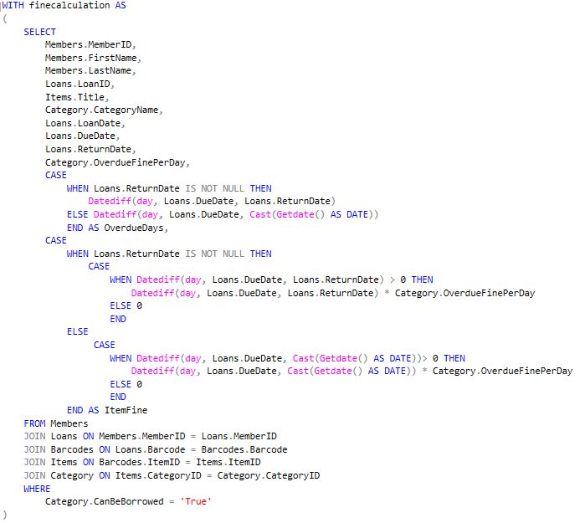
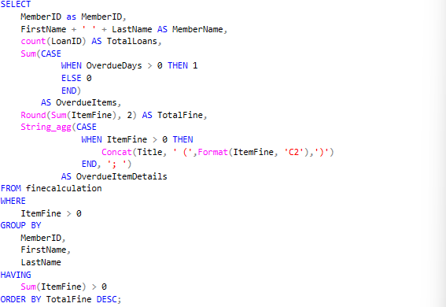
Figure 3.6.1: DML query for Question 6

3.6.2 Query Result
Figure 3.6.2.1: Query result for Question 6

3.6.3 Explanation

WITH finecalculation AS(...)
Creates a temporary table titled ‘finecalculation’ which is used to perform queries and acts as a sub-query to the main query.

CASE
WHEN Loans.ReturnDate IS NOT NULL THEN
Datediff(day, Loans.DueDate, Loans.ReturnDate)
ELSE Datediff (day, Loans.DueDate, Cast(Getdate()AS DATE))
END AS OverdueDays,
This case function returns the number of days a borrowed book is overdue as ‘OverdueDays’.

CASE
WHEN Loans.ReturnDate IS NOT NULL THEN
CASE
WHEN Datediff(day, Loans.DueDate, Loans.ReturnDate)>0 THEN
ELSE Datediff (day, Loans.DueDate, Loans.ReturnDate) *
Category.OverdueFinePerDay
ELSE 0
END
ELSE
WHEN Datediff(day, Loans.DueDate,Cast(Getdate()AS DATE))>0 THEN
ELSE Datediff (day, Loans.DueDate,Cast(Getdate()AS DATE)) *
Category.OverdueFinePerDay
ELSE 0
END
END AS ItemFine
This case function returns the total fine accumulated for all the unreturned items for each member as ‘ItemFine’. It calculates the date differences from the due dates of items to be returned and the day it is returned or today if the member still has not returned it and multiplicates it with each item’s fine per day.

WHERE Category.CanBeBorrowed = ‘True’
- Ensures that the item can be borrowed

SELECT
MemberID AS MemberID,
FirstName + ‘ ‘ + LastName AS MemberName,
- Combine the FirstName column with LastName to create a new column containing the full name of members called ‘MemberName’.

COUNT(LoanID) AS TotalLoans,
- Calculates the total number of borrowed item for each member.

SUM(CASE WHEN OverdueDays > 0 THEN 1
ELSE 0) AS OverdueItems,
- Calculates the total number of late returned items for each member.

ROUND(SUM(ItemFine), 2) AS TotalFine,
- Calculates the total fine for each member.

STRING_AGG(CASE WHEN ItemFine>0 THEN
CONCAT (Title, ‘ (‘, Format(ItemFine, ‘C2’), ‘)’)
END, ‘ ;’) AS OverdueItemDetails,
- Shows the details of each overdue items.

FROM finecalculation
- Selects data from ‘finecalculation’ for queries.

WHERE ItemFine>0
HAVING SUM(ItemFine) > 0
- Filter out data of members without fines

GROUP BY
MemberID,
FirstName,
LastName
- The GROUP clause groups the Members first name, and last name.

ORDER BY TotalFine DESC;
- Order the query result by the amount of total fine per member from most to least.

3.7 Question 7 - Roger Rusdijanto Purnomo (TP075718)
Show members who have reserved a meeting room more than three times in the last month.

3.7.1 SQL Code
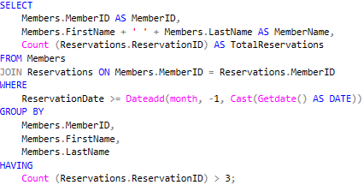
Figure 3.7.1: DML query for Question 7

3.7.2 Query Result
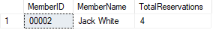
Figure 3.7.2: Query result for Question 7

3.7.3 Explanation
SELECT
Members.MemberID AS MemberID,
FirstName + ‘ ‘ + LastName AS MemberName,
- Combine the FirstName column with LastName to create a new column containing the full name of members called ‘MemberName’.

COUNT (Reservations.ReservationID) AS TotalReservations
- Calculates the number of reservations made by a member.

FROM Members
- Selects data from ‘Members’ table for queries.

JOIN Reservations ON Members.MemberID=Reservations.MemberID
- links the Reservation and Member table using MemberID where it includes records where the MemberID is present in both tables.

WHERE Reservations >= Dateadd(month, -1, Cast(Getdate() AS Date))
- Filters out reservations so only reservations made within the last month will be calculated.

GROUP BY
Members.MemberID,
Members.FirstName,
Members.LastName
- The GROUP clause groups the Members first name, and last name.

HAVING COUNT(Reservations.ReservationID) > 3
- Filter out data where members made less than 3 reservations.

3.8 Question 8 - Gerrend Alfredo (TP081484)
Display the most popular genre of items (books, DVDs, etc.) based on the number of times items in that genre have been borrowed.

3.8.1 SQL Code
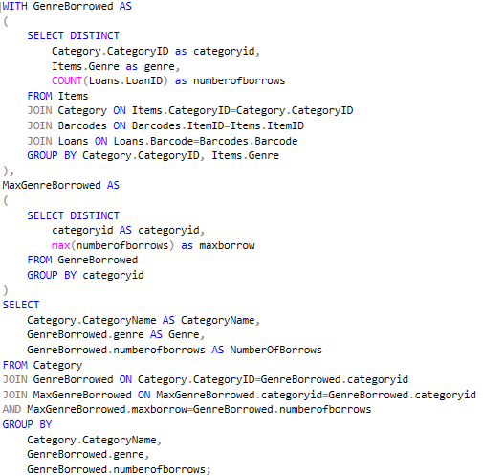
Figure 3.8.1: DML query for Question 8

3.8.2 Query Results
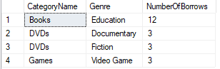
Figure 3.8.2: Query result for Question 8

3.8.3 Explanation
WITH GenreBorrowed AS (...), MaxGenreBorrowed AS (...)
The WITH clause creates a Common Table Expression (CTE) name GenreBorrowed.

(SELECT DISTINCT
Category.CategoryID as categoryid,
Items.Genre as genre,
COUNT(Loans.LoanID) as numberofborrows
FROM Items
JOIN Category ON Items.CategoryID=Category.CategoryID
JOIN Barcodes ON Barcodes.ItemID=Items.ItemID
JOIN Loans ON Loans.Barcode=Barcodes.Barcode
GROUP BY Category.CategoryID, Items.Genre),
Inside GenreBorrowed:
- The SELECT DISTINCT clause selects unique CategoryID and genre and calculates the amount borrowed using the COUNT(Loans.LoanID) function.
- JOIN Category ON Items.CategoryID=Category.CategoryID links the Items and Category table using CategoryID where it includes records where the CategoryID is present in both tables.
- JOIN Barcodes ON Barcodes.ItemID=Items.ItemID links the Items and Barcodes table using ItemID where it includes records where the ItemID is present in both tables.
- JOIN Loans ON Loans.Barcode=Barcodes.Barcode links the Barcodes and Loans table using Barcode where it includes records where the Barcode is present in both tables.
- The GROUP BY clause groups the results by the category and genre to ensure proper aggregation and uniqueness as the number of borrows is per genre per category.

(SELECT DISTINCT
categoryid AS categoryid,
max(numberofborrows) as maxborrow
FROM GenreBorrowed
GROUP BY categoryid)
Inside MaxGenreBorrowed
- The SELECT DISTINCT clause will select unique CategoryID and return the maximum number of borrowings for that category.
- The max(numberofborrows) returns the maximum number of borrow per category.
- The GROUP BY clause will group the results based on the unique CategoryID, preventing duplication

SELECT
Category.CategoryName AS CategoryName,
GenreBorrowed.genre AS Genre,
GenreBorrowed.numberofborrows AS NumberOfBorrows
The SELECT clause selects category and genres and the number of borrow per genre per category.

FROM Category
JOIN GenreBorrowed ON Category.CategoryID=GenreBorrowed.categoryid
JOIN MaxGenreBorrowed ON MaxGenreBorrowed.categoryid=GenreBorrowed.categoryid
AND MaxGenreBorrowed.maxborrow=GenreBorrowed.numberofborrows
The JOIN clause will link two tables with each other using an identifier. The JOIN clause used is as follows:
- JOIN GenreBorrowed ON Category.CategoryID=GenreBorrowed.categoryid links the Category and GenreBorrowed table using CategoryID which will include records with the same CategoryID in both tables.

- JOIN MaxGenreBorrowed ON MaxGenreBorrowed.categoryid=GenreBorrowed.categoryid AND MaxGenreBorrowed.maxborrow=GenreBorrowed.numberofborrows links the MaxGenreBorrowed and the GenreBorrowed table using categoryid and includes those records where the categoryid is the same and the number of borrows is equal to the maximum number of borrow per category.

GROUP BY
Category.CategoryName,
GenreBorrowed.genre,
GenreBorrowed.numberofborrows;
The GROUP BY clause will group the results based on the unique CategoryName, Genre and Number of borrows, preventing duplication of records.

3.9 Question 9 - Lee Chong Yew (TP084402)
Write a query to find the number of meeting rooms that are available on 12 October 2024. Order by room number.

3.9.1 SQL Code
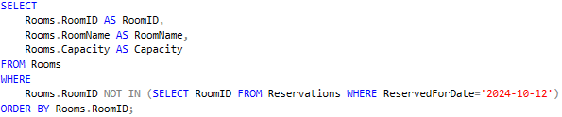
Figure 3.9.1: DML query for Question 9

3.9.2 Query Results
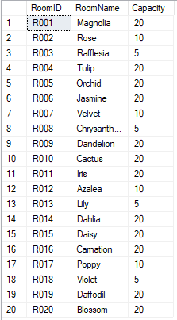
Figure 3.9.2: Query result for Question 9

3.9.3 Explanation
SELECT
Rooms.RoomID AS RoomID,
Rooms.RoomName AS RoomName,
Rooms.Capacity AS Capacity
FROM Rooms

- The SELECT clause returns all the RoomIDs, RoomNames and their corresponding capacity from the Rooms table.

WHERE
Rooms.RoomID NOT IN (SELECT RoomID FROM Reservations WHERE ReservedForDate = ‘2024-10-12’

- The SELECT subquery creates a result set of RoomIDs of rooms that are reserved for the 12th of October 2024.
- The outer WHERE clause and NOT IN modifier filters the results to only show RoomIDs of rooms that are not booked for the 12th of October 2024.
ORDER BY Rooms.RoomID;

- The ORDER BY clause sorts the result set in ascending order according to the Room IDs.

3.10 Question 10 - Kay Nouvell Sidik (TP079470)
List out all rooms that have been reserved in the month of July 2024. Show them according to the activity

3.10.1 SQL Code
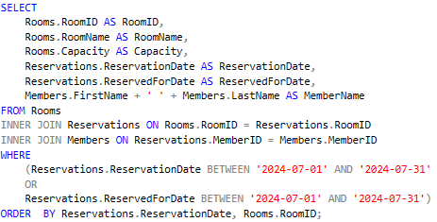
Figure 3.10.1: DML query for Question 10

3.10.2 Query Result
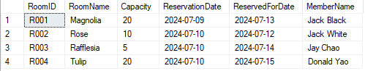
Figure 3.10.2: Query result of Question 10

3.10.3 Explanation
SELECT
Rooms.RoomID AS RoomID,
Rooms.RoomName AS RoomName,
Rooms.Capacity AS Capacity,
Reservations.ReservationDate AS ReservationDate,
Reservations.ReservedForDate AS ReservedForDate,
Members.FirstName + ‘ ’ + Members.LastName AS MemberName
FROM Rooms

- The SELECT clause returns the RoomIDs, RoomNames, their corresponding capacities, ReservationDates and ReservedForDates from the Rooms table.

FROM Rooms
INNER JOIN Reservations ON Rooms.RoomID = Reservations.RoomID
INNER JOIN Members ON Reservations.MemberID = Members.MemberID

- The INNER JOIN clause is used to link the Rooms and Reservations tables together, using the RoomID column as a common field.
- The INNER JOIN clause is used to link the Reservations and Members tables together, using the MemberID column as a common field.

WHERE
(Reservations.ReservationDate BETWEEN ‘2024-07-01’ AND ‘2024-07-31’
OR
Reservations.ReservedForDate BETWEEN ‘2024-07-01’ AND ‘2024-07-31’)

- The WHERE clause filters the query to only show entries of reservations that are either booked on or booked for any day in the month of July 2024.

ORDER BY Reservations.ReservationID, Rooms.RoomID

- The ORDER BY clause sorts the result set in ascending order according to ReservationID then ascending order according to RoomID.

3.11 Question 11 - Lee Chong Yew (TP084402)
Show the number of books written by each author, sort the result according to book count (author with most books sorted on top).

3.11.1 SQL Code
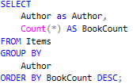
Figure 3.11.1: DML query for Question 11

3.11.2 Query Results
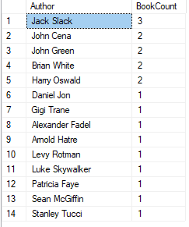
Figure 3.11.2: Query result of Question 11

3.11.3 Explanation
SELECT
Author as Author,
Count(*) AS BookCount
From Items
- Author as Author → Retrieves the ‘Author’ column which is from ‘Items’ table then it will be labeled as Author in the result/output
- COUNT(*) AS BookCount → This part will count the total number of rows which is ‘books’ for each Author and then it will be labeled as BookCount in the result/output
- From Items → This will take the data from the ‘Items’ table

GROUP BY
Author
- GROUP BY Author → This will group the row in the table as ‘Author’

Order by BookCount Desc;
- This will sort the result according to the BookCount in descending order, which means that the Author with the most number of books will be on top and the Author with the least number of book will appear at the bottom

3.12 Question 12 - Sonny Sanputra (TP084754)
Display members have neither borrowed items nor reserved rooms in the year 2023.

3.12.1 SQL Code
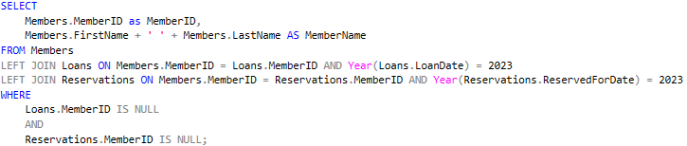
Figure 3.12.1: DML query for Question 12

3.12.2 Query Result
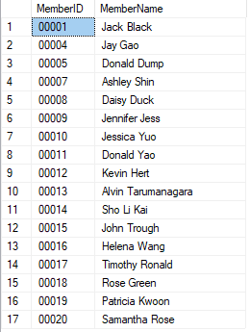
Figure 3.12.2: Query result of Question 12

3.12.3 Explanation
SELECT
Members.MemberID as MemberID,
Members.FirstName + ' ' + Members.LastName AS MemberName
- Members.MemberID as MemberID → This will select the ‘MemberID’ from ‘Member’ table then it will be labelled as MemberID in the output/result table
- Members.FirstName+ ' ' +Member.LastName AS MemberName → This will select the FirstName and LastName from the Member table and concatenate them with a space between them so for an example if the FirstName is Sonny and LastName is Sanputra so the result will be 'Sonny Sanputra'

FROM Members
- FROM Members → This will take the data from the Members table

LEFT JOIN Loans in Members.MemberID = Loans.MemberID AND Year(Loans.LoanDate) = 2023
- This will join the MemberID from Members table and Loans table, and it filters the loans that are only made in the year 2023 by using ‘Year()’ on the LoanDate. The ‘LEFT JOIN’ will ensure that even if there are no members who doesn’t have loans in the year 2023 will still appear in the result/output but will NULL values

LEFT JOIN Reservations on Members.MemberID = Reservations.MemberID AND Year(Reservations.ReservedForDate) = 2023
- Similarly like the previous one, this ‘LEFT JOIN’ will link the ‘Members’ table with the ‘Reservations’ table by joining on the ‘MemberID’ and it filters the reservations that is only done in the year 2023 by using the function ‘Year()’ on the ReservedForDate. Just like before the members without any reservations made will result in a NULL value result for the reservations detail

WHERE
Loans.MemberID IS NULL
AND
Reservations.MemberID IS NULL;
- Loans.MemberID IS NULL → This will filter the results in order to include the member that does not have any loans in 2023 in the result
- Reservations.MemberID IS NULL → This will filter the results in order to also include the members who do not have any reservations in 2023 in the result

3.13 Question 13 - Kay Nouvell Sidik (TP079470)
Among the books borrowed in the year 2024, show the list of books that cost the most.

3.13.1 SQL Code
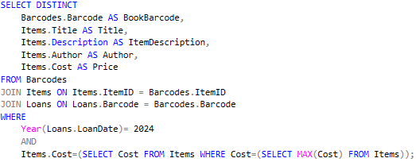
Figure 3.13.1: DML query for Question 13

3.13.2 Query Result
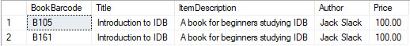
Figure 3.13.2: Query result of Question 13

3.13.3 Explanation
SELECT DISTINCT
Barcodes.Barcode AS BookBarcode,
Items.Title AS Title,
Items.Description AS ItemDescription,
Items.Author AS Author,
Items.Cost AS Price
FROM Barcodes
The SELECT DISTINCT clause selects the Barcode, Title of the item, Description of the item, Author and Cost and identifies them accordingly. The DISTINCT ensures that no duplicate or repeated records occur.

FROM Barcodes
JOIN Items ON Items.ItemID = Barcodes.ItemID
JOIN Loans ON Loans.Barcode = Barcodes.Barcode
The JOIN clause will link two tables with each other using an identifier. The JOIN clause used is as follows:
- JOIN Items ON Items.ItemID = Barcodes.ItemID links the Items and Barcodes table using ItemID which will include records with the same ItemID in both tables.
- JOIN Loans ON Loans.Barcode = Barcodes.Barcode links the Loans and Barcodes table using Barcode which will include records with the same Barcode in both tables.

WHERE
Year(Loans.LoanDate)= 2024
AND
Items.Cost=(SELECT Cost FROM Items WHERE Cost=(SELECT MAX(Cost) FROM Items))
The WHERE clause filters records based on the following conditions:
- Year(Loans.LoanDate)= 2024 where loans occur during the year 2024, hence the item must be borrowed during 2024.
- Items.Cost=(SELECT Cost FROM Items WHERE Cost=(SELECT MAX(Cost) FROM Items) where the item’s price or cost must be equal to the highest price of all the items in the Items table.
- It will choose only those items which has the highest price and are borrowed in the year 2024.

3.14 Question 14 - Roger Rusdianto Purnomo (TP075718)
Show the publisher whose books are least-in-quantity by genre.

3.14.1 SQL Code
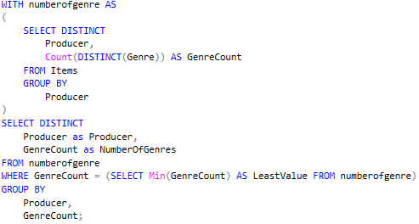
Figure 3.14.1: DML query for Question 14

3.14.2 Query Result
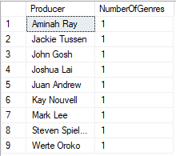
Figure 3.14.2: Query result of Question 14

3.14.3 Explanation
WITH numberofgenre AS (...)
The WITH clause creates a Common Table Expression (CTE) named numberofgenre.

(SELECT DISTINCT
Producer,
Count(DISTINCT(Genre )) AS GenreCount
FROM Items
GROUP BY Producer)
Inside the numberofgenre:
- (COUNT(DISTINCT(Genre)) calculates the number of unique genres associated with each producer in the items table. The result includes producer and the count of unique genres as GenreCount.
- GROUP BY PRODUCER ensures that the count is calculated for each producer uniquely.

SELECT DISTINCT
Items.Producer,
numberofgenre.GenreCount
FROM Items
The SELECT DISTINCT clause retrieves unique combinations of producers and their corresponding GenreCount. It eliminates duplication of Producer.

FROM Items
JOIN numberofgenre ON Items.Producer = numberofgenre.Producer
The JOIN clause links the items table with the numberofgenre CTE using identifier Producer
This ensures that the query includes producers that exists in both tables along with their calculated GenreCount.

WHERE
numberofgenre.genrecount = (SELECT Min(GenreCount) AS LeastValue FROM numberofgenre)
The WHERE clause filters the results to include only those producers whose GenreCount matches the least number of genres using the (MIN(genrecount)).

GROUP BY items.producer,
numberofgenre.GenreCount;
The GROUP BY clause groups the results by producer and their corresponding GenreCount to ensure proper uniqueness.

3.15 Question 15 - Gerrend Alfredo (TP081484)
Show the number of male member(s) who have reserved the rooms in the library whose age are more than the average age.

3.15.1 SQL Code
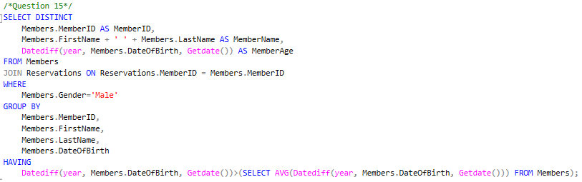
Figure 3.15.1: DML query for Question 15

3.15.2 Query Result

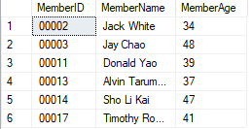
Figure 3.15.2: Query result of Question 15

3.15.3 Explanation
WITH MaleMembers AS (...)
The WITH clause creates a Common Table Expression (CTE) name MaleMembers.

(SELECT DISTINCT
Members.MemberID AS MemberID,
Members.FirstName + ' ' + Members.LastName AS MemberName,
Datediff(year, Members.DateOfBirth, Getdate()) AS MemberAge
FROM Members
JOIN Reservations ON Reservations.MemberID = Members.MemberID
WHERE
Members.Gender='Male'
GROUP BY
Members.MemberID,
Members.FirstName,
Members.LastName,
Members.DateOfBirth)
Inside MaleMembers:
- The SELECT DISTINCT clause selects unique MemberID and names and calculates their age using the DATEDIFF function.
- Datediff(year, Members.DateOfBirth, Getdate()) is used to calculate the age of the member, where it finds the difference in the amount of year between the current data and the date of birth.
- JOIN Reservations ON Reservations.MemberID = Members.MemberID links the Members and Reservations table using the MemberID, where records which contain the same MemberID in both tables are only included.
- The WHERE clause filters so that only members that are male are included.
- The GROUP BY clause groups the results by MemberID, FirstName, LastName, and DateOfBirth to ensure proper aggregation and uniqueness.

SELECT
MaleMembers.MemberID,
MaleMembers.MemberName,
MaleMembers.MemberAge
FROM MaleMembers
The SELECT clause selects MemberID and names and their age from the MaleMembers table.

RIGHT JOIN Members on MaleMembers.MemberID=Members.MemberID
The RIGHT JOIN clause links the MaleMembers and Members table, where the Members table is the dominant table, which is used to count the average age.

GROUP BY
MaleMembers.MemberID,
MaleMembers.MemberName,
MaleMembers.MemberAge,
Members.DateOfBirth
The GROUP BY clause groups the results by MemberID, Name, Age and DateOfBirth to ensure proper aggregation and uniqueness.

HAVING
MaleMembers.MemberAge>(SELECT AVG(Datediff(year, Members.DateOfBirth, Getdate())) FROM Members);
- SELECT AVG(Datediff(year, Members.DateOfBirth, Getdate())) FROM Members will return the average age of all members.
- This acts as a filter so that only members with age greater than the average age of all members is included.

Section 4 - References
Hightouch. (2023, December 29). SQL with - syntax, use cases, and examples. https://hightouch.com/sql-dictionary/sql-with
International Business Machines (IBM). (2024, November 19). SQL Identifiers. https://www.ibm.com/docs/en/idr/11.4.0?topic=elements-sql-identifiers
Programiz. SQL JOINS
https://www.programiz.com/sql/join
W3schools.com. W3Schools Online Web Tutorials. (n.d.).
https://www.w3schools.com/sql/

Section 5 - Workload Matrix

Part | Component | Chong Yew | Roger | Kay | Gerrend | Sonny | Total
2 | a) Database Schema | / | / | / | / | / | 100%
2 | b) Data Definition Language | / | / | / | / | / | 100%
2 | c) Data Manipulation Language | / | / | / | / | / | 100%

